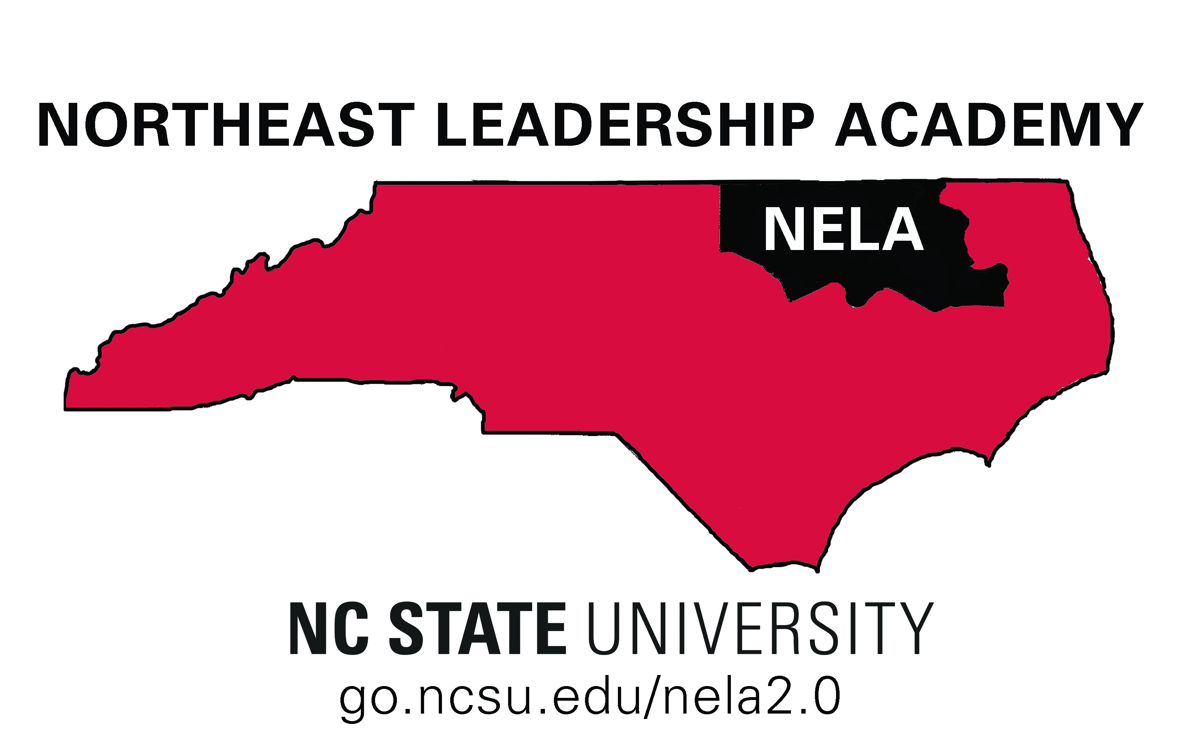
The NELA Principal Academy Speed Mingle Activity is meant to "speed up" the process of meeting or getting reacquainted. We are going to participate in a “round-robin” or “musical chairs” technique that will allow you to meet the participating principals one-on-one for 2 minutes (or less). We know that the premise is a bit absurd, but it should be a fun and efficient way to begin the process of building strong professional relationships.
NELA Principal Academy
Speed Mingle

Procedures:
- Two rows of participants are facing each other. If your back is to the door, you will remain seated for the entire activity. If you are facing the door, you will move one seat to your right each time the bell rings.
- Each person has only one minute to speak each round. Begin by telling your name and then answer the question for that round.
- At the end of the Speed Mingle, you will introduce the Round 11 person to the group.

Round 1: | If you were a superhero, what power would you possess and how would you use it?
Round 2: | If you could have dinner with the two people (living or dead) that best exemplify leadership qualities you respect, who would they be (explain)?
Round 3: | What is your favorite “App” and why?
Round 4: | What is the first thing you check on your phone in the morning?
Round 5: | If you were one age for all of your life…what age would that be and why?
Round 6: | Where do you get most of your news?
Round 7: | If you were to write your autobiography, what would the title be and why?
Round 8: | What has been your most powerful learning experience? (Could be a formal or informal educational experience).
Round 9: | Where is your favorite vacation spot?
Round 10: | Why did you decide to become a principal?
Round 11: | What do you hope to learn from this professional development opportunity this week?

